Blessing Igbadumhe
T: 832-226-9260  bigbadumhe@gmail.com
experience
Mastercard https://www.mastercard.com 2021-present
Mastercard Inc. is an American multinational financial services corporation. I worked with the mobile and web team to design and develop the different online products the company uses to drive success.
- Developed architecture design for various services
- Developed various UI designs from prototype for web and mobile app
- Improved various AWS lambdas per agile stories
- Contributed to optimizing business logic for various lambdas
- Code reviewed other developers work

DREAM CHASE TECHNOLOGY LLC 2020-2021
Dream Chase is a company that trains Software Engineers and assign their candidates in organizations to acquire real world experience or absorb the candidate internally to handle the company’s projects. Depending on what the candidate chooses.
Software Engineer
- Wrote stable and maintainable codebases with react.
- Implemented a mobile first approach to existing websites.
- Created modular, responsive templates using CSS5 and JavaScript libraries.
- Assisted with the transition from a waterfall method to the more efficient agile methodology.
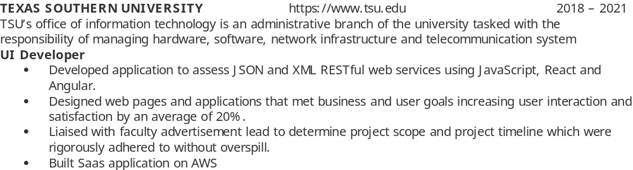
Consultant developer https://www.blessingigbadumhe.com 2010 – present
After acquiring knowledge and developing a passion for building online interfaces, I have used my knowledge in adding value to organizations and businesses.
Web and Mobile Developer.
- Handling all verbal and written communications between hosting companies, clients, and vendors.
- Meeting with prospective clients to review website and gather the client’s specifications for new or existing websites.
- Managing Linux servers using shell access for freelance and client websites.
- Designing and coding new website for the alumni association of Texas Southern University using sass, HTML, JavaScript, jQuery and PHP.
- Solved problems with an emphasis on producing scalable, efficient, and maintainable solutions with Linux/ubuntu and PHP/Laravel
EDUCATION
Computer Science (M.Sc.)
Texas Southern University
- Relevant Courses: Cryptography, Algorithms and Data Structures, Database, Big Data, Data Analysis
Business Information Systems & Information Technology (B.Sc.)
Middlesex University
- Relevant Courses: UI/UX design, Strategic Information Systems, Business Intelligence, UG project (designed and developed CRM application).

Skills
- Expertise in building apps with ReactJS and React Native
- Highly proficient in JavaScript, HTML, CSS, and Node
- Strength in developing responsive, pixel-perfect designs
- Extensive knowledge in software development life cycle.
- Skilled in development with Agile methodology
- Sound knowledge in object-oriented programming as well as functional programming
- Extensive experience implementing popular programming design patterns (MVC, Singleton, Factory, Module).
Technical
Software development: JavaScript, Nodejs, React, AWS, Azure, MongoDB, SaaS, MySQL.

